**CSS, font**

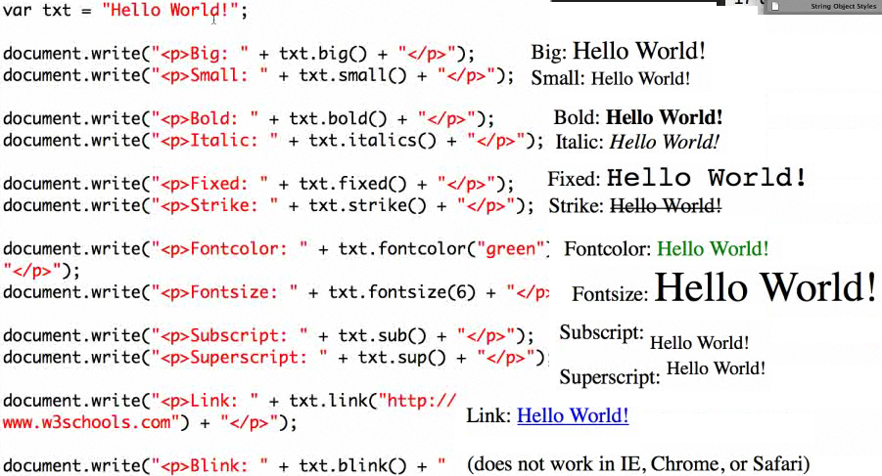

**INNER TEXT**

|  |  |
| --- | --- |
| [ sTxt **=** ] *object*.**innerText** | <BUTTON onclick="oPara.**innerText**='It changed!'">Change text</BUTTON> |

**FONT**

|  |  |
| --- | --- |
| { font : sFont } | <SPAN **STYLE="font:italic normal bolder 12pt Arial">** |
| [ sFont **=** ] *object*.**style.font** | <DIV  onmouseover=  "this.**style.font = 'italic small-caps bold 12pt serif'**">  </DIV> |
| [ sFont **=** ] *object*.**style.font** | <STYLE>  .color1 { color:red }  .color2 { color:green }  </STYLE>  </HEAD>  <BODY>  <SPAN STYLE="font-size:14" onmouseover="this.**className**='color1'"  onmouseout="this.**className**='color2'"> . . . |

**BORDER COLOR**

|  |  |
| --- | --- |
| { border-color : sColor } | <head>  <style type="text/css">  TD {  border-color: red;  border-width: 0.5cm;  border-style: solid;  }  .WithBlue {  border-style: groove;  border-color: blue;  }  </style>  </head> |
| [ sColor **=** ] *object*.**style.borderColor** | <table border="">  <tr>  <td **onmouseover="this.className='WithBlue'"**  **onmouseout="this.className=''">**  <img alt="sphere" src="sphere.jpg"> </td>  </tr>  </table> |

**BACKGROUND**

|  |  |
| --- | --- |
| { background-color : sColor } | <span **style="font-size: 14px; background-color: lime">**  The background color of the text has been set inline using the <b>background-color</b> attribute.</span> |
| [ sColor **=** ] *object*.**style.backgroundColor** | <b>background-color</b> attribute. |